

NATIONAL POLICE COMMISSION

**PHILIPPINE NATIONAL POLICE, POLICE REGIONAL OFFICE CALABARZON**

**CAVITE POLICE PROVINCIAL OFFICE**

**CARMONA MUNICIPAL POLICE STATION**

J.M. Loyola Street, Brgy. Maduya, Carmona, Cavite

October 2021

2021-10-411

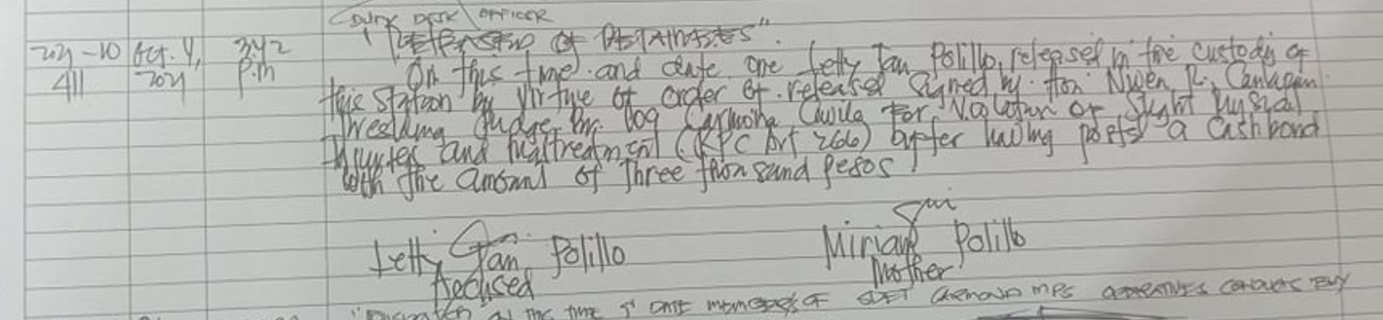

2021-10-415

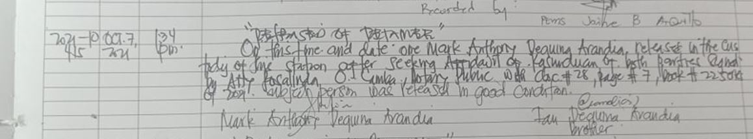

2021-10-416

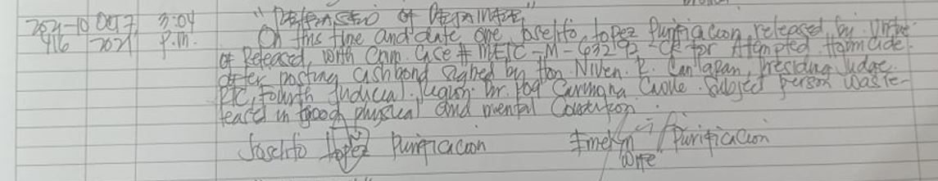

2021-10-419

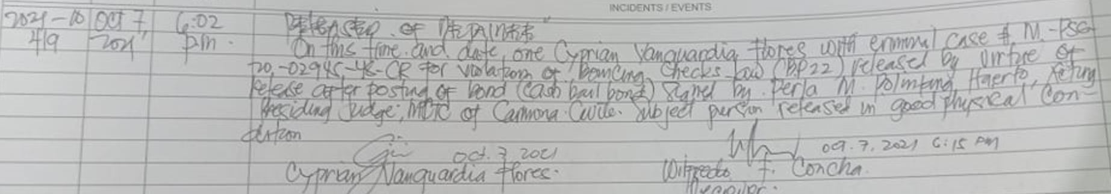

2021-10-427

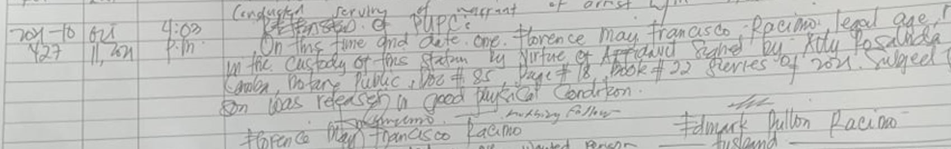

2021-10-429

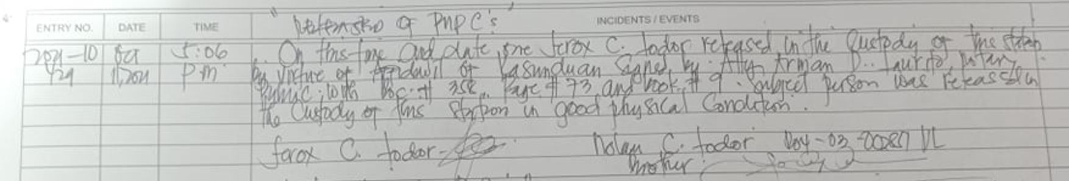

2021-10-430

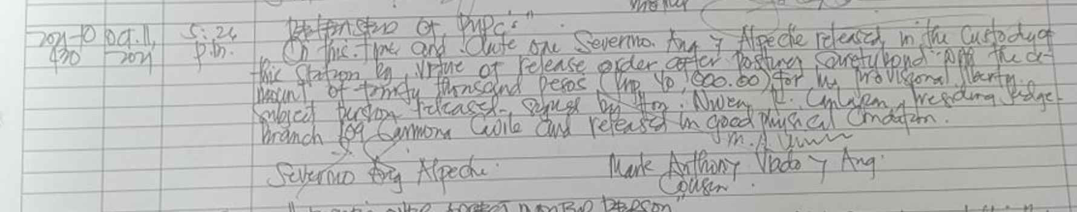

2021-10-432

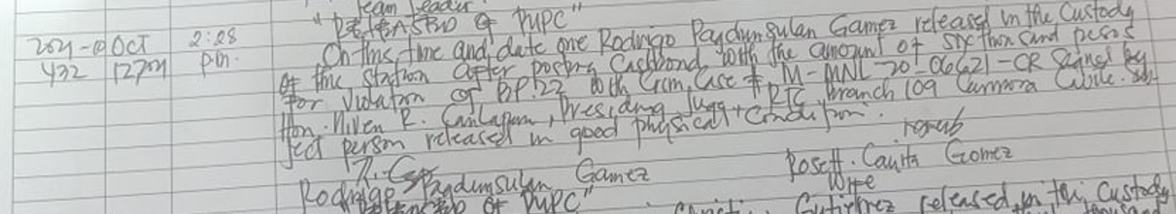

2021-10-433

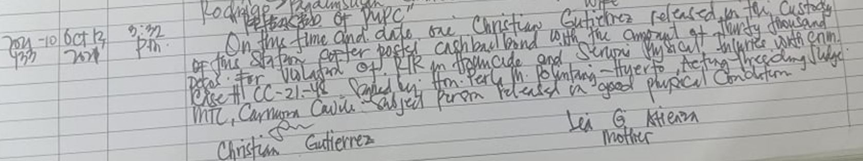

2021-10-434

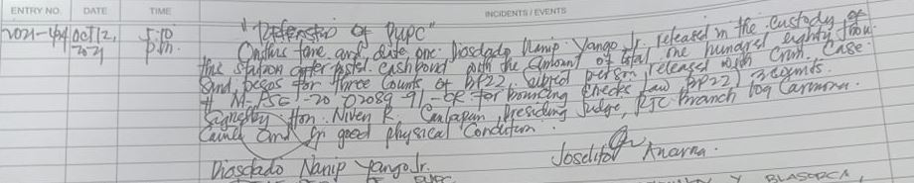

2021-10-435

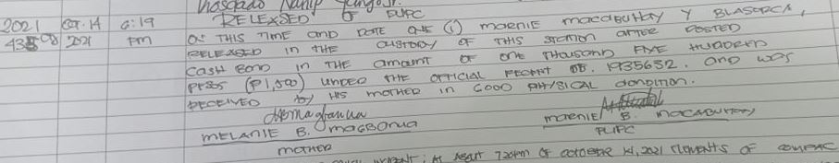

2021-10-438

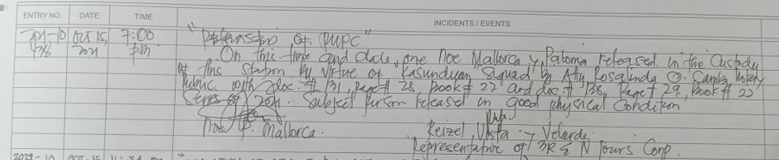

2021-10-440

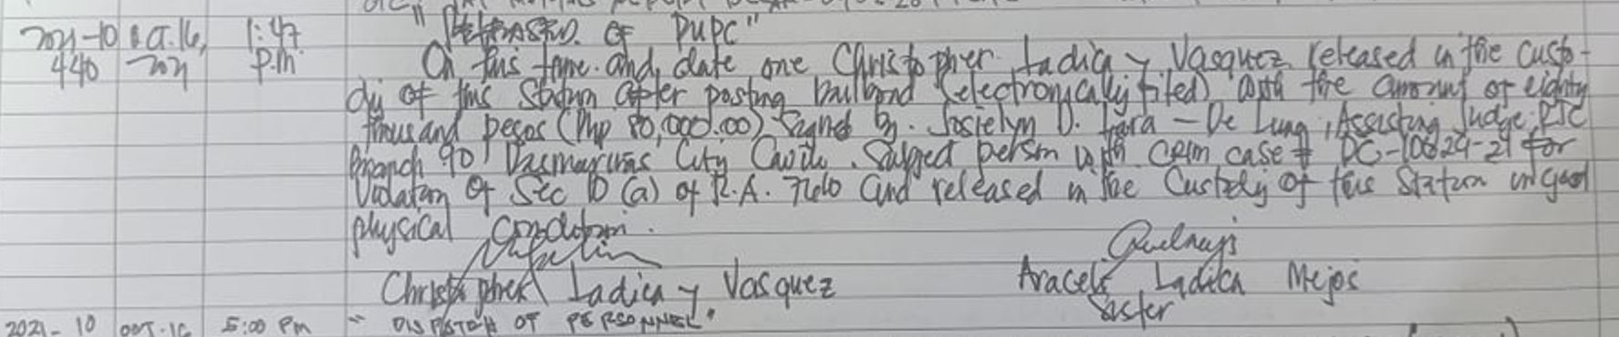

2021-10-447

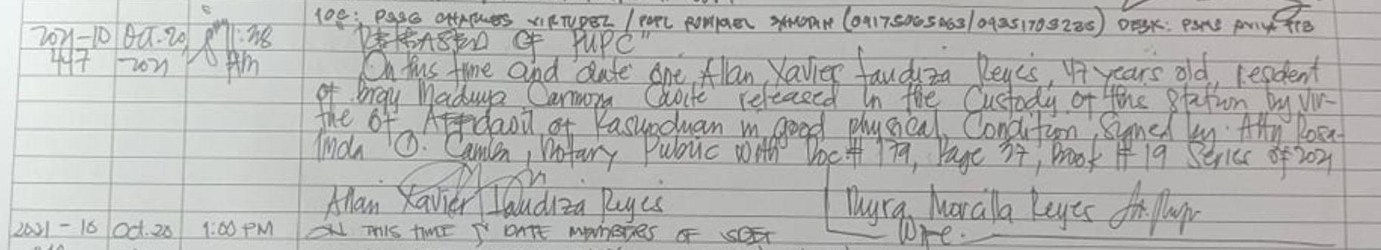

2021-10-464

